TWIN RIVERS PARISH COUNCIL

THE ORDINARY MEETING OF THE COUNCIL WILL BE HELD
IN THE VILLAGE HALL ON TUESDAY 9th September 2025

You are summoned to attend.
Public Forum 7.30-7. 40pm.Any members of the public attending the meeting may be given (at the chairman’s discretion) a combined 10-minute time slot to address councillors on any items of concern or interest. After this period the public are welcome to stay for the full parish council meeting but CANNOT speak nor offer advice/opinion on any matter. This public participation is NOT part of the parish council meeting and as such there are no rights to record this part of the meeting in any way.

AGENDA

Apologies for absence.

Minutes

The minutes of the last meeting held on 8th July 2025 have been circulated to all councillors prior to the meeting.

Declarations of Interest.

Declaration of Interest – The parish councils (Model Code of Conduct Order 2011). To record any declarations of interest by any member in respect of items on this agenda). Members declaring interests should identify the agenda item and type of interest being declared.
Financial Matters

Current account - £

Cow lane Current account -

Business reserve £

Cheques
Clerks wages
Spay
Defib batteries- £356.80

ONGOING ISSUES

Ousefleet Community Hall update.

Health and Safety Issues.

Cow Lane

PLANNING
Replacement of Nave and North and South Aisle slate roof coverings with Terne Coated Stainless Steel (Re-Submission of 24/03414/PLF) Location: St Mary Magdalene Church Main Street Whitgift East Riding Of Yorkshire DN14 8HL

TPO - ADLINGFLEET NO.1 - 1976 (REF 2) G1 - ADLINGFLEET CONSERVATION AREA - T2 Lime: Crown reduce with selective pruning of the northern lower crown to clear the BT line by 1 metre only; T3 Lime: Crown reduce with selective pruning of the northern lower crown to clear the BT line by 1 metre only and crown lift low descending branch south to provide 2.4m clearance from ground; T4 Lime: Crown reduce with selective pruning of the northern lower crown to clear the BT line by 1 metre only; T5 Lime: Crown reduce with selective pruning of the northern lower crown to clear the BT line and pole by 1 metre only and removal of hanging branch west of neighbouring property Location: Church Farm Garthorpe Road Adlingfleet East Riding Of Yorkshire DN14 8JB

Listed Building Consent for the removal of two metal water tanks and concrete flooring to second floor Location: The Hall Main Street Whitgift East Riding Of Yorkshire DN14 8HL

Change of use of outbuildings to wedding and events venue comprising ceremony barn, function barn with catering kitchen and storage block, erection of entrance porch to function barn and pergola, installation of new wall cladding and doors and creation of additional vehicular access, erection of 2m high boundary fence to separate venue from the dwelling 'White House' and associated landscaping and car parking following partial demolition of existing piggery building (Resubmission of 24/01022/PLF) Location: White House Piggeries Narrow Lane Ousefleet East Riding Of Yorkshire DN14 8HW - Refusal

COUNCILLOR ISSUES
Two co options exist, Advertised on the website, noticeboards and in the Goole Times.

National grid

Whitgift lighthouse

Speeding

Newsletter

Planters

Phone Box

Road between Adlingfleet and Ousefleet

Church lane

Ousefleet village hall roof

Footpaths

Tree

Penfold

Information Board

CORRESPONDENCE

WARD COUNCILLOR’S REPORTS

ITEMS FOR THE NEXT AGENDA

Date and place of the next meeting

14th October 2025. 7:30pm Ousefleet village hall

Signed

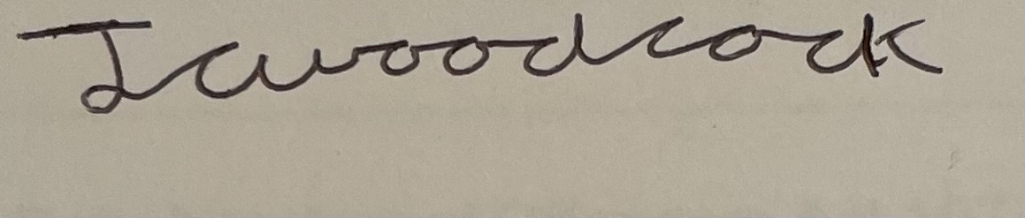
James Woodcock- Clerk and RFO

